**How to Connect an S3 Bucket to CloudFront (Step-by-Step Guide)**

**Step 1: Create an S3 Bucket**

1. log in to the **AWS Management Console**.
2. Navigate to **S3** 🡪 Click **Create bucket**.

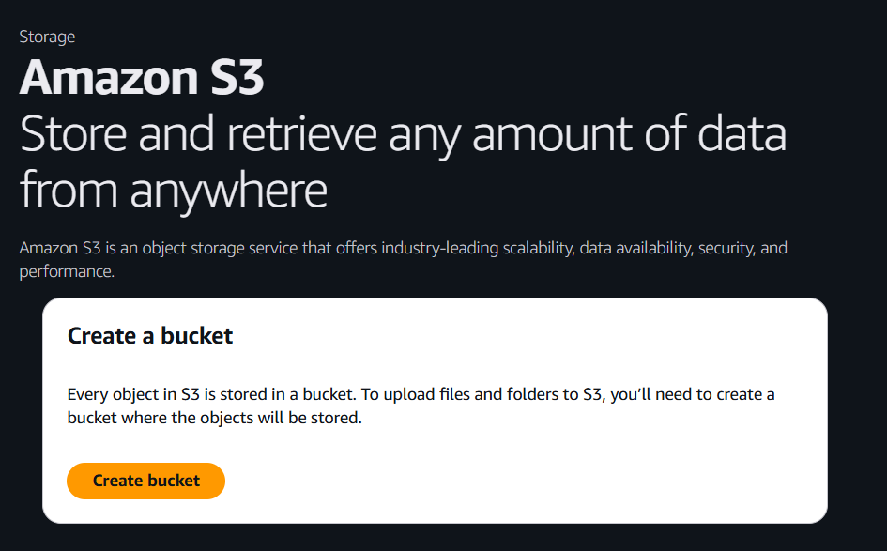

1. Note The bucket name must be unique across **all existing bucket names in Amazon S3**, not just your account.
2. Give Enter a **unique bucket name**

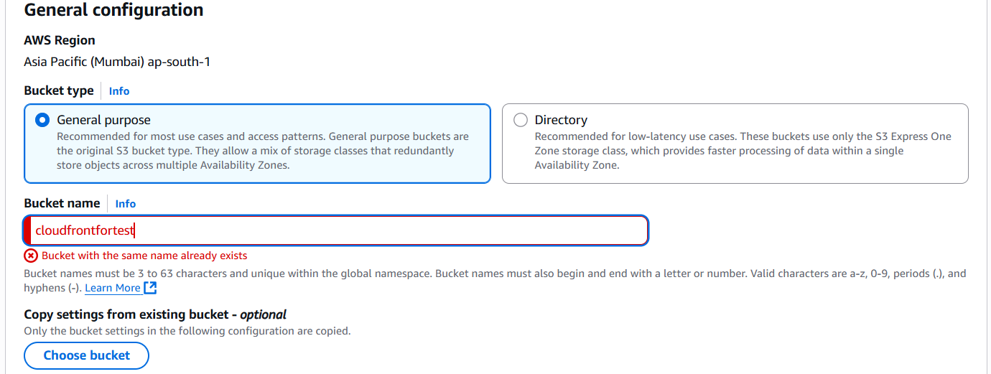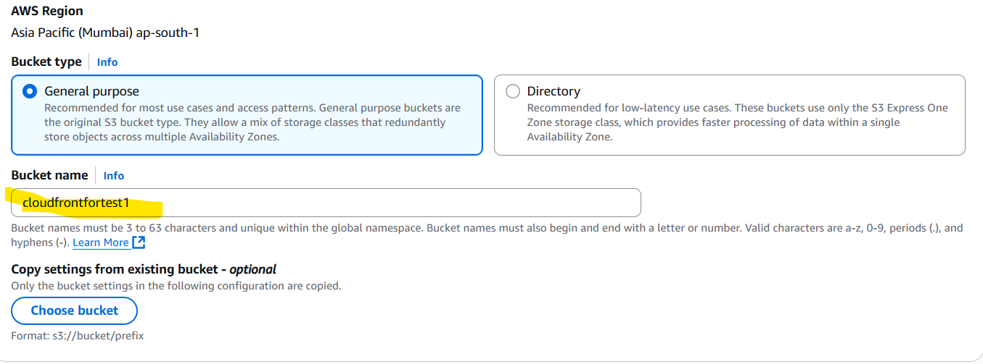

1. Create bucket

**Step 2: Upload Files to the Bucket**

1. Upload the files or video in objects

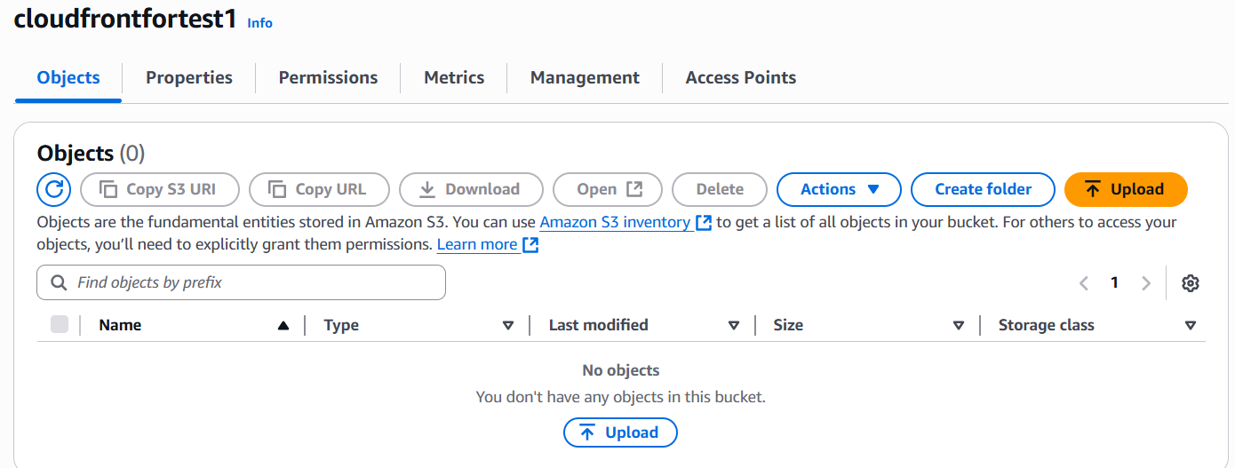

1. Add files 🡪 select the files.
2. Select the priorities of storage class

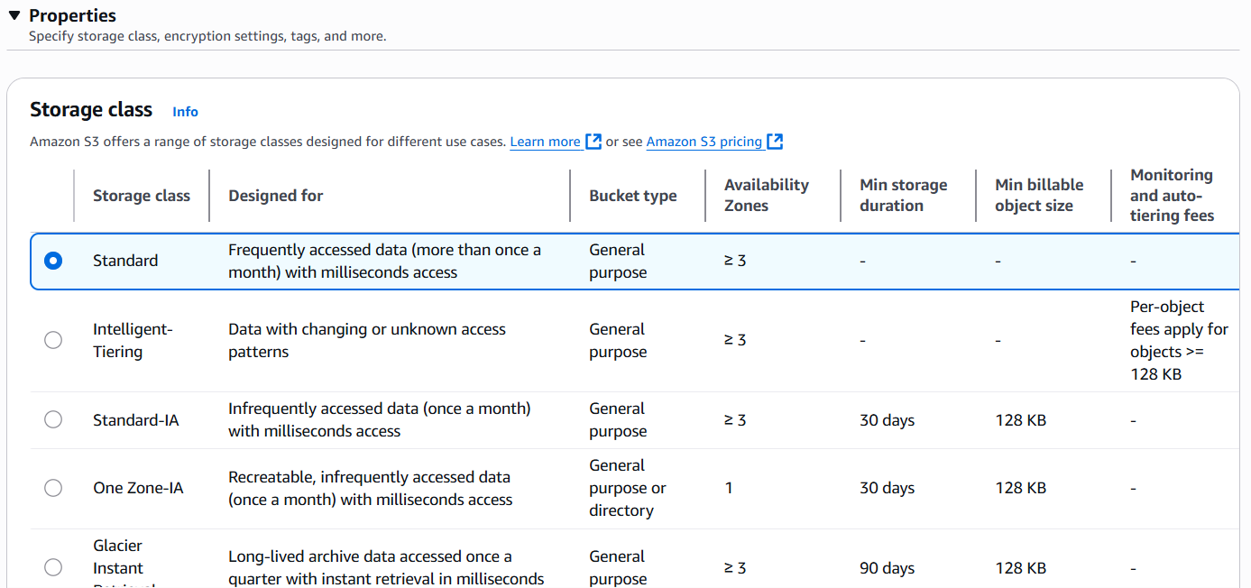

1. Try hit using the S3 bucket URL

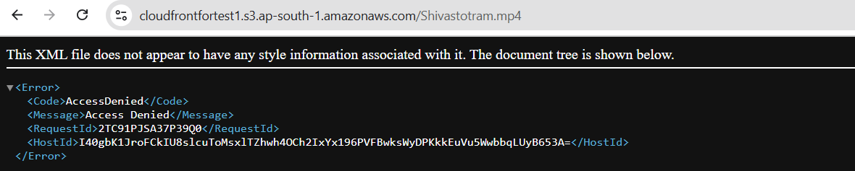

1. Change object permission as a public. Now we are able to reach the hit using the s3 URL.



**Using the Cloud Front will connect the S3 BUCKET**

**Step 3: Set Up a CloudFront Distribution**

1. Go to **CloudFront** in the AWS Console.

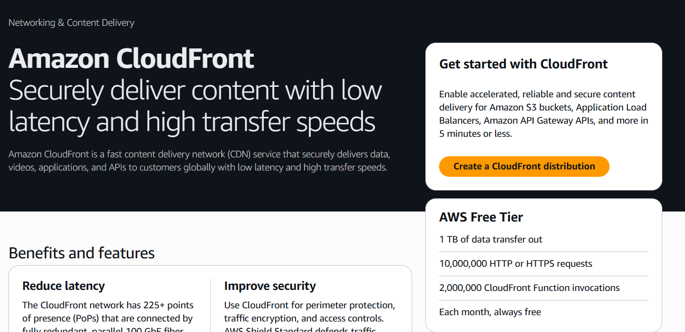

1. Create a distribution.
2. Origin Domain 🡪 select the S3 bucket
3. Origin Access 🡪 Origin access control settings (recommended)

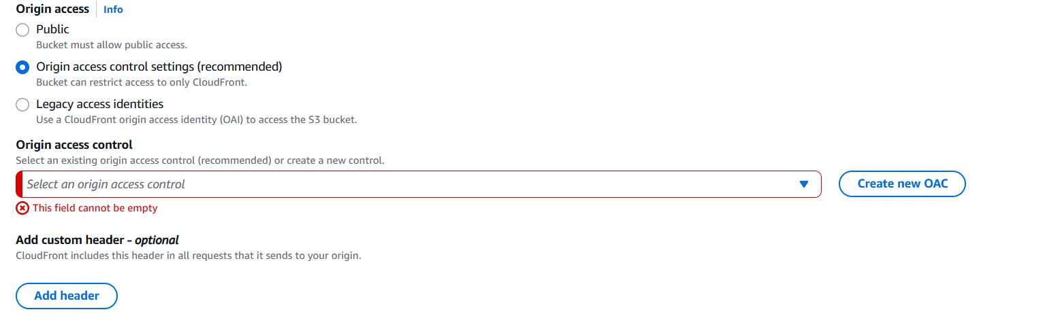

1. Select the origin access control if exist or create new OAC.

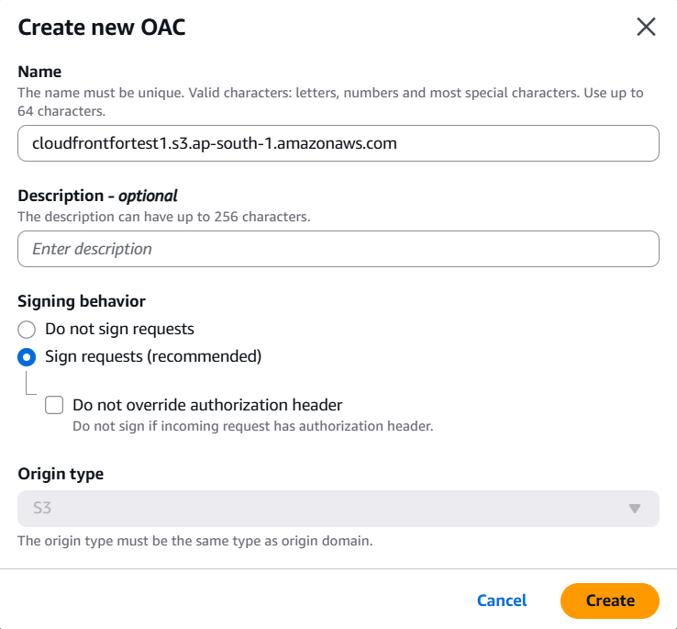

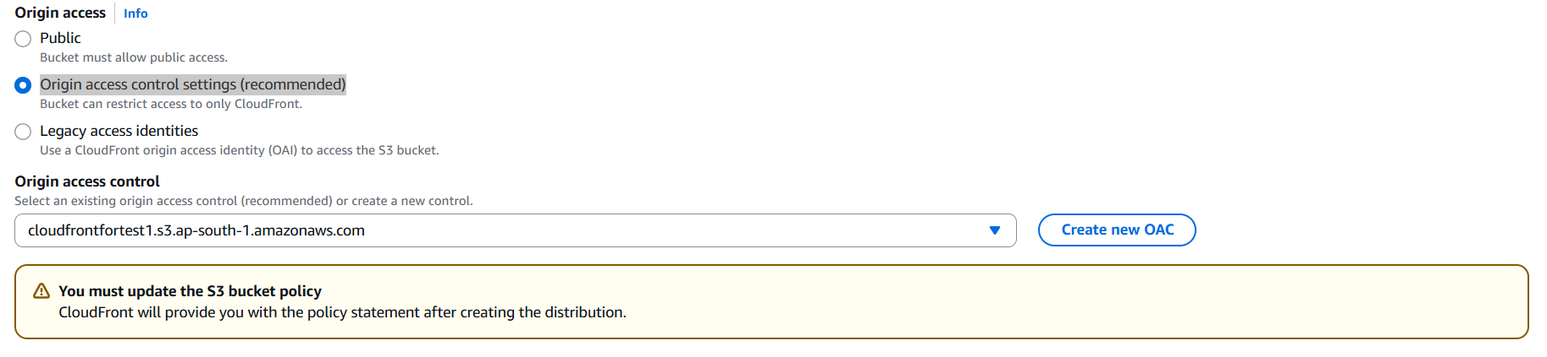

1. After creating the distribution CloudFront will provide the policy. This policy needs to be add in S3 bucket policy.

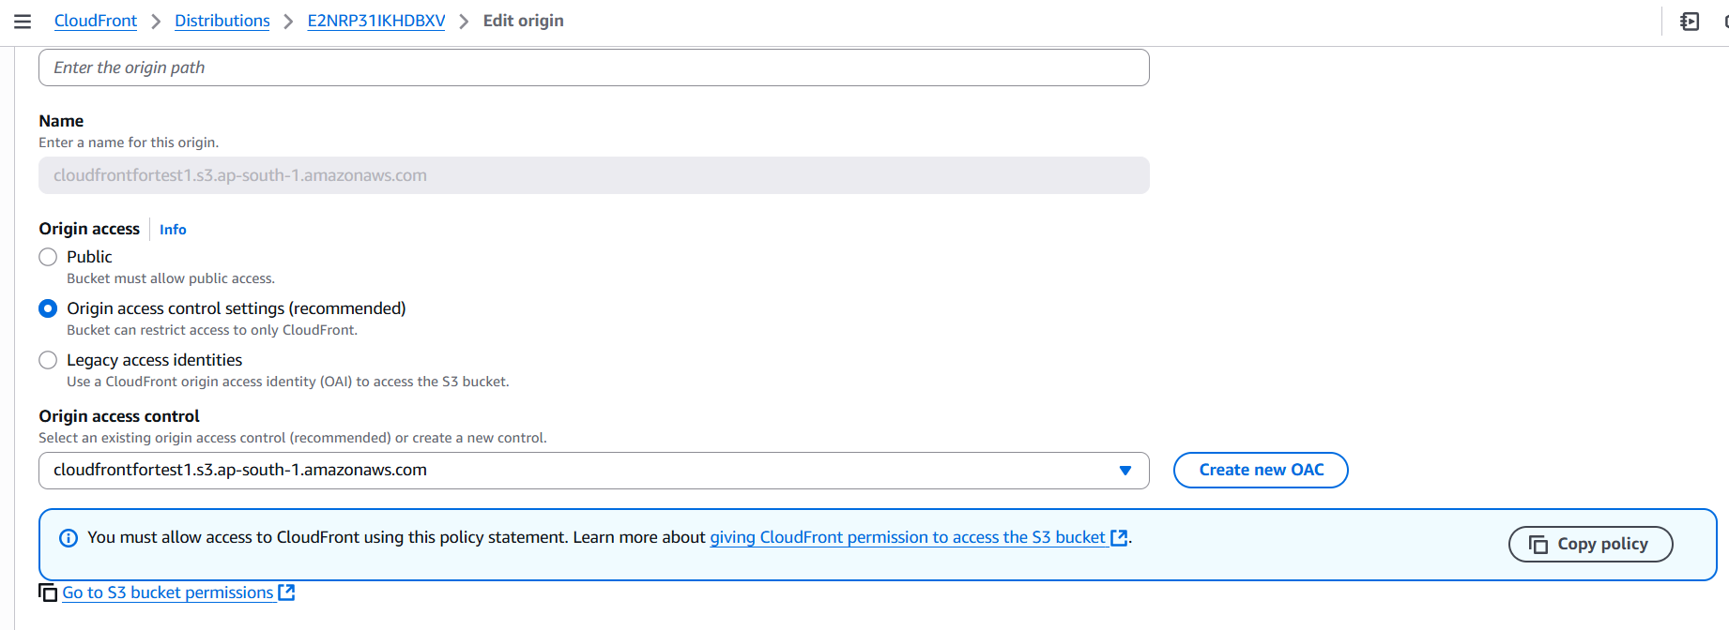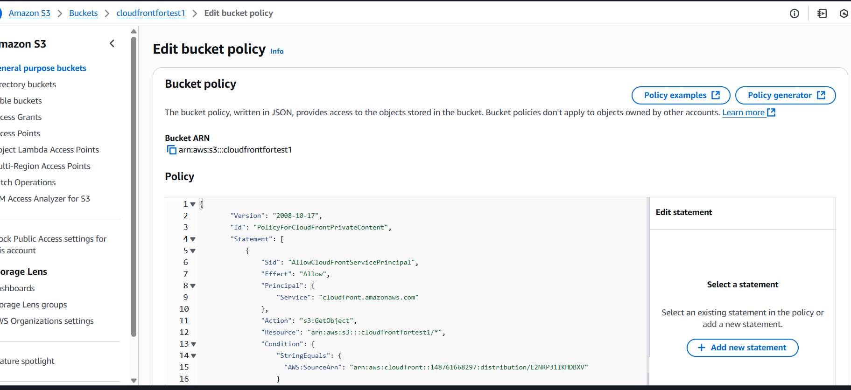

1. CloudFront will give a domain name, you can hit the using URL /object name. it’ll give the output of object.

